Guidance for DivineCall candidates

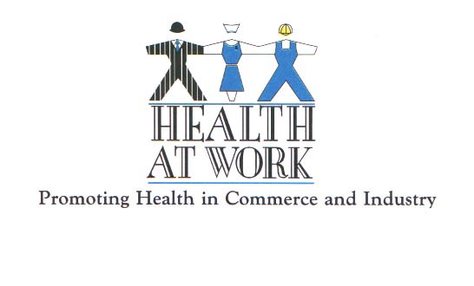
Please read this important advice to help you complete your Confidential Health Declaration.

- A Certificate of Fitness to Practice is now a contractual requirement when working for the National Health Service through an NHS National Contract Approved Supplier.

- At Health at Work your Health Declaration will only be handled by staff who acts according to the strict confidentiality criteria applied to health and personal information. If your declaration is fully completed, and all the requested documentation is provided, the necessary authority and certificate will be returned to your agency within 24 hours, enabling them to find suitable work for you.

- Please understand that occupational health requirements for NHS positions, particularly in relation to communicable disease, are becoming increasingly strict. These requirements place obligations upon agencies and are not an “optional extra”. Health at Work will not be able to provide a certificate if the information you supply is incomplete. Without a certificate, your agency will not be able to provide you with work.

- We offer the following points to help you: they reflect the problems which most frequently occur. When these problems happen, we have to return the forms to you, with a corresponding delay:

General Comments

- Answer the questions fully and accurately; read the footnotes. You MUST provide details where requested: a simple tick will not suffice.

- Health at Work can only make a decision based on evidence, which it is your responsibility to provide.

- Answer the question about Exposure Prone Procedures carefully. Read the footnote, and if necessary, consult the Department of Health advice to which it refers. All Hepatitis B and Hepatitis C tests must be taken in an NHS department of Occupational Health or on an Identity Validated Sample. The result must make this clear. You also need to address the questions about hepatitis C and HIV. Most of the problems we have in relation to this issue come from clinicians saying they undertake EPP when they do not. Check the Department of Health website. Remember that even if you do not undertake EPPs your Hepatitis B test must be on an Identity Validated Sample.

- For some questions (e.g. Varicella, see below), a self declaration is acceptable; for others, documentary evidence is required. There is no flexibility: where documentary evidence is required, its absence prevents further assessment of your declaration.

- If you have been through a similar process with an NHS Department of Occupational Health, (for example, for a substantive position) or with another agency, they may have provided you with a satisfactory OH document which may suffice for one or more pieces of evidence: there is no intention to duplicate investigations. However, in this context “satisfactory” means providing the evidence in an acceptable form - for example a dated record of rubella serology or a dated record of rubella vaccine administration.

- Where you are submitting laboratory or radiology results, a good quality copy is acceptable, but it must contain your name exactly as in the rest of your documentation. Reports which use code numbers instead of names (which some laboratories use to improve within - trust confidentiality) are not acceptable. The copy must carry the stamp of the original issuing body or the agency certifying that the original has been seen.

- Serology from an approved UK laboratory may be acceptable, but the source of the test result must be clearly identifiable and the result comprehensible. Results for Hepatitis B which are not from the UK must be on an Identity Validated Sample.

- Where a CXR is indicated, you must provide a copy of the report. A self declaration is not acceptable. An overseas CXR or report is not acceptable.

Specific Conditions

- Tuberculosis. Evidence of your having a positive tuberculin test or of having received BCG vaccine is required. If the latter, confirmation from a competent individual that you have an appropriate scar at the site of injection is also required. A self declaration is not acceptable. Documentary evidence can be provided on the attached form, completed by an Occupational Health Nurse or an experienced Doctor. It must be signed, dated and stamped. A CXR may be required, depending on recent work and travel. Radiology, must have been performed in the UK.

- Hepatitis B. Serology must be provided on an Identified Validated Sample: Evidence of vaccine administration is not sufficient. Where surface antibody levels are above 100 miu/l, no further evidence is required. Where the level is below 10 miu/l, evidence of further testing to exclude hepatitis B infection may be required.

- HIV. A declaration is required if you have tested positive. Please remember your professional obligations when making your declaration.

- Varicella. Following guidance issued by the Chief Medical Officer in December 2003, self-declaration of a history of varicella is acceptable. If, however, you have tested negative and you work in an acute medical or surgical specialty (including O&G and on-call), vaccination is required and confirmation from GP / hospital is required that vaccination has been given

- Rubella. Evidence of positive rubella serology is required (from both males and females) if your work may bring you into contact with female patients who are or may be pregnant.

